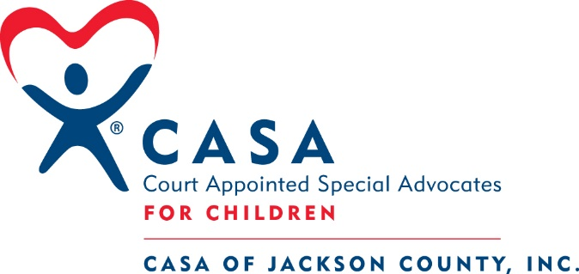

Planned Giving: Make a Life Changing Gift
Did you know there are ways to support CASA of Jackson County that will not affect your current lifestyle or your family's security? You can support CASA with gifts that do not impact the way you live by designating CASA of Jackson County to receive estate assets in the future, or by making immediate gifts to us of assets that are "out of sight and out of mind." We call these "Gifts Anyone Can Make" because anyone can make them now without impacting cash flow, lifestyle, or family security.

The Benefits
- You can make a gift that costs you nothing during your lifetime.
- You can make a gift that leaves your cash flow and current financial planning unchanged.
- You don't have to use cash to make your gift; you can "buy low and give high" by making your gift with appreciated securities instead.
- You can give an asset you no longer need or want.
Gifts from Your Will or Trust
Need to preserve your assets during your lifetime? You can plan a gift to us that will only take effect after your other obligations have ceased.
- Include a bequest to CASA in your will or trust.
- Make your bequest unrestricted or direct it to a specific purpose.
- Indicate a specific amount, or a percentage of the balance remaining in your estate or trust.
Gifts from a Retirement Plan
Give us assets subject to double taxation, then leave more to your family.
- Name CASA as a beneficiary of your IRA, 401(k), or other qualified plan.
- Designate us to receive all or a portion of the balance of your plan through your plan administrator.
- The balance in your plan passes to CASA after your death.
Gifts of Stock and Appreciated Assets
Here is how to take advantage of appreciated securities without incurring capital gains tax.
- You transfer appreciated stocks, bonds, or mutual fund shares you have owned for more than one year to CASA.
- CASA sells your securities and uses the proceeds for its programs.
Gifts of Life Insurance
You don't need a large estate to make a significant gift to us. Here's how you can leverage your dollars for a larger gift.
- You transfer ownership of a paid-up life insurance policy to CASA.
- CASA elects to cash in the policy now or hold it.

541-734-2272 | www.jacksoncountycasa.org | 613 Market Street, Medford, Oregon 97504

